LINEAR INTEGRATED CIRCUIT

LABORATORY

SHARDA KUMARI

BT20EC001

ELECTRONICS AND COMMUNICATION ENGINEERING

**EXPERIMENT - 1**

**AIM OF THE EXPERIMENT:**

Build the MOS differential amplifier and determine Common Mode

Rejection Ratio (CMRR) using multisim software

**APPARATUS REQUIRED:**

PC loaded with multisim software

**THEORY:**

The MOSFET is by far the most widely used transistor in both digital and analog circuits, and it is the backbone of modern electronics. One of the most common uses of the MOSFET in analog circuits is the construction of differential amplifiers.

The latter are used as input stages in op-amps, video amplifiers, high-speed comparators, and many other analog-based circuits. MOSFET differential amplifiers are used in integrated circuits, such as operational amplifiers, they provide a high input impedance for the input terminals.

A properly designed differential amplifier with its current-mirror biasing stages is made from matched-pair devices to minimize imbalances from one side of the differential amplifier to the other.

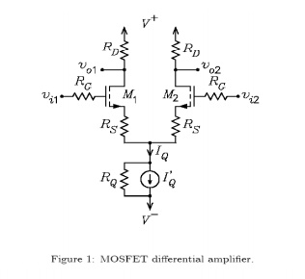

**IMPLEMENTATION:**

Circuit Diagram

**MOS Differential**

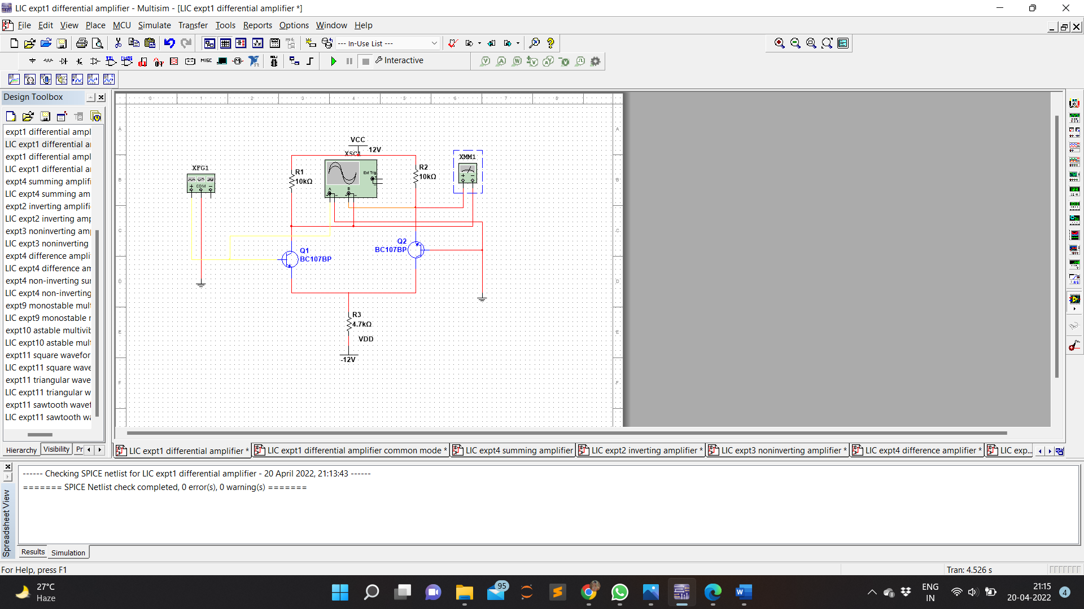

**MOS Differential Common Mode**

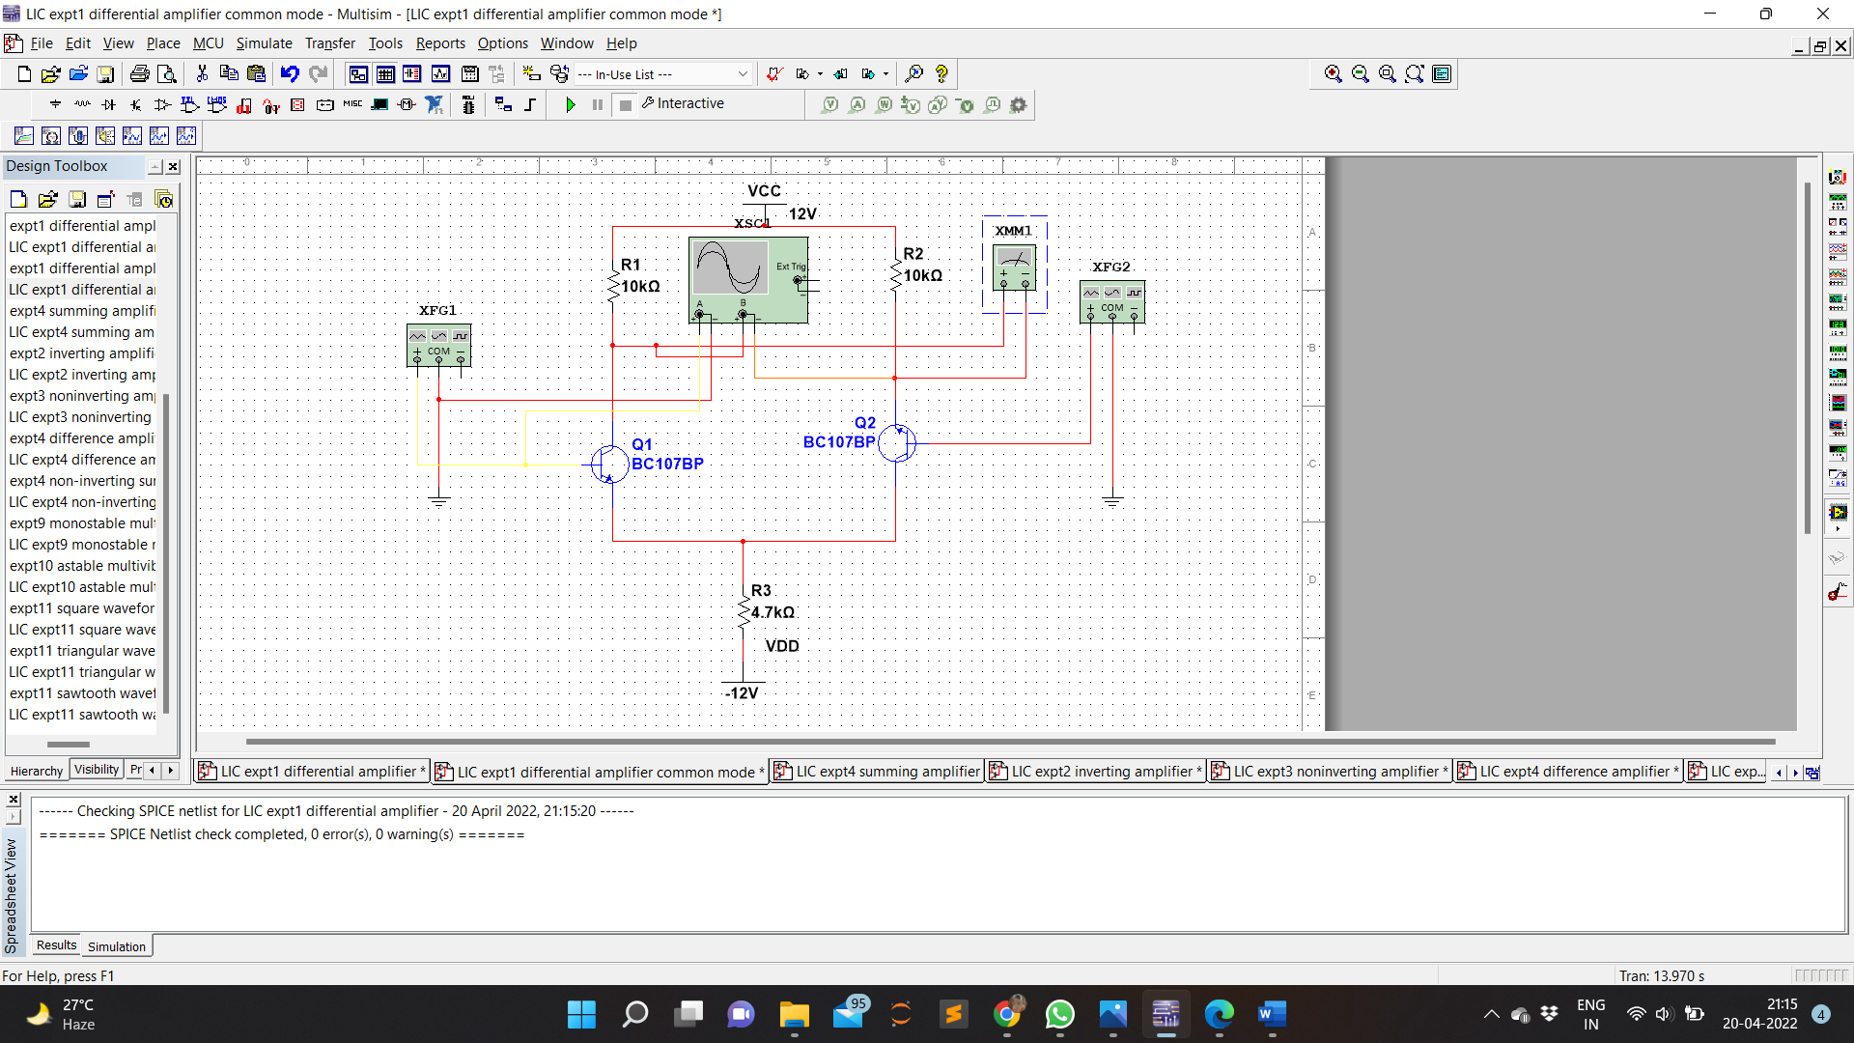

Waveform

**MOS Differential**

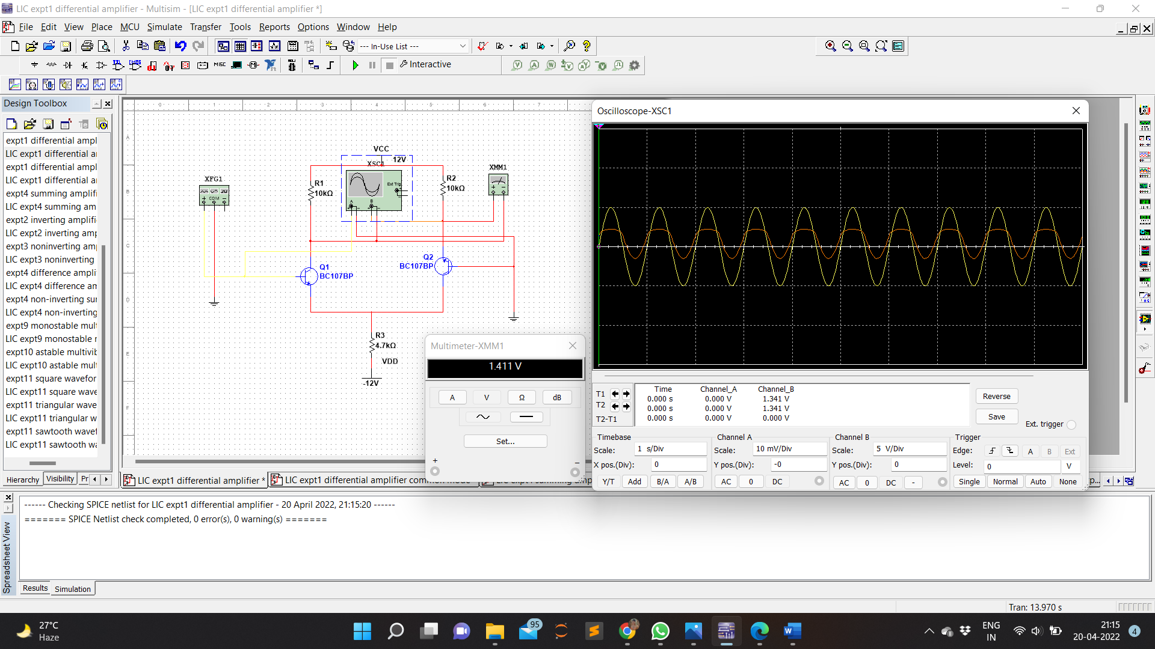

**MOS Differential Common Mode**

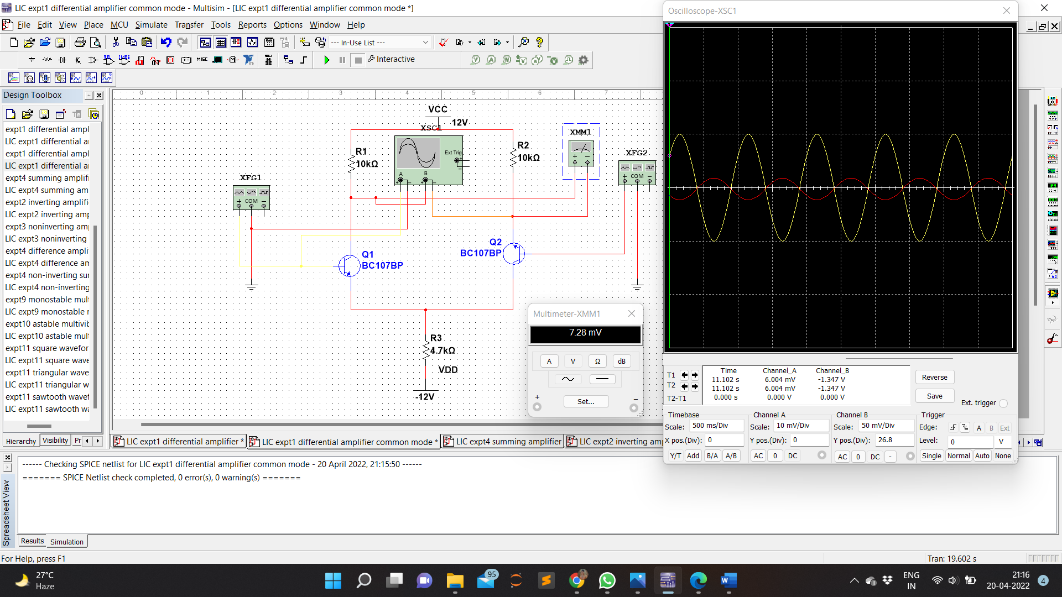

**CALCULATION:**

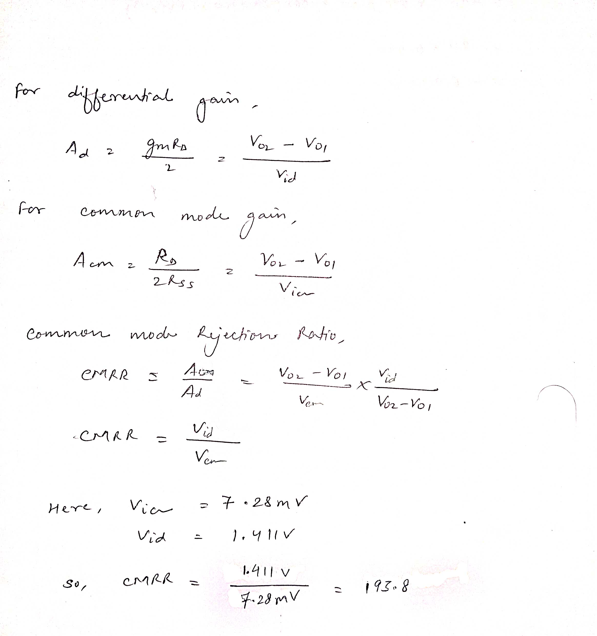

**RESULT:**

MOS differential amplifier was designed and simulated and CMRR was calculated using the circuit designed and simulated.